STEREO HEADSET
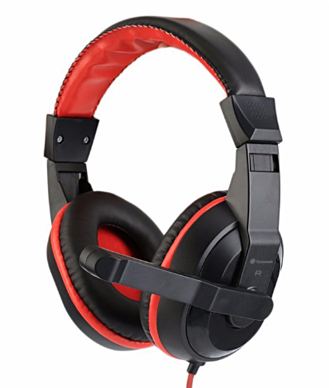
DH-500

Descrption:

The DH-500 is a featured, over-the-head Stereo Headphone system using our ClearSound™ audio technology to give great audio feedback no matter what audio applications, and is the perfect partner for Business, MP3 or for just creating an exciting sound experience for the latest Games.

The DH-500 comes with large, cushioned ear cups attached to durable ergonomic adjustable headband designed to provide comfort during extended use.

With its built-in adjustable Microphone for VoIP applications like Skype®, this premium Stereo Headset provides great performance coupled with great value.

Weighing in at 182g the DH-500 is perfect headset for everyday business or personal use

.SPECIFICATIONS:
  - Driver Diameter: Φ40mm
  - Headset Impedance: ≥322
  - Frequency Response: 16- 20KMZ
  - Headset Sensitivity: 115.0DB土3DB
  - Input Plug Diameter: Φ3.5mm
  - Mic Dimension: Φ6.0x5.0mm
  - Mic Sensitivity: -58DB±3DB
  - Mic Impedance: ≥2.2KΩ
  - Directivity: Omnidirectional
  - Cord Length: 2.3 Meters

